 | Curriculum Vitae _ Omar A. Imran .
Objective .
To earn a position of responsibility in the fields of Electrical Engineering (electronic engineering, electrical energy, Renewable energy), that enables me to utilize my skills and theoretical expertise to deal with electrical energy and electronics problems. In addition, my postgraduate degrees enable me to university teaching and working.
 |  |  | 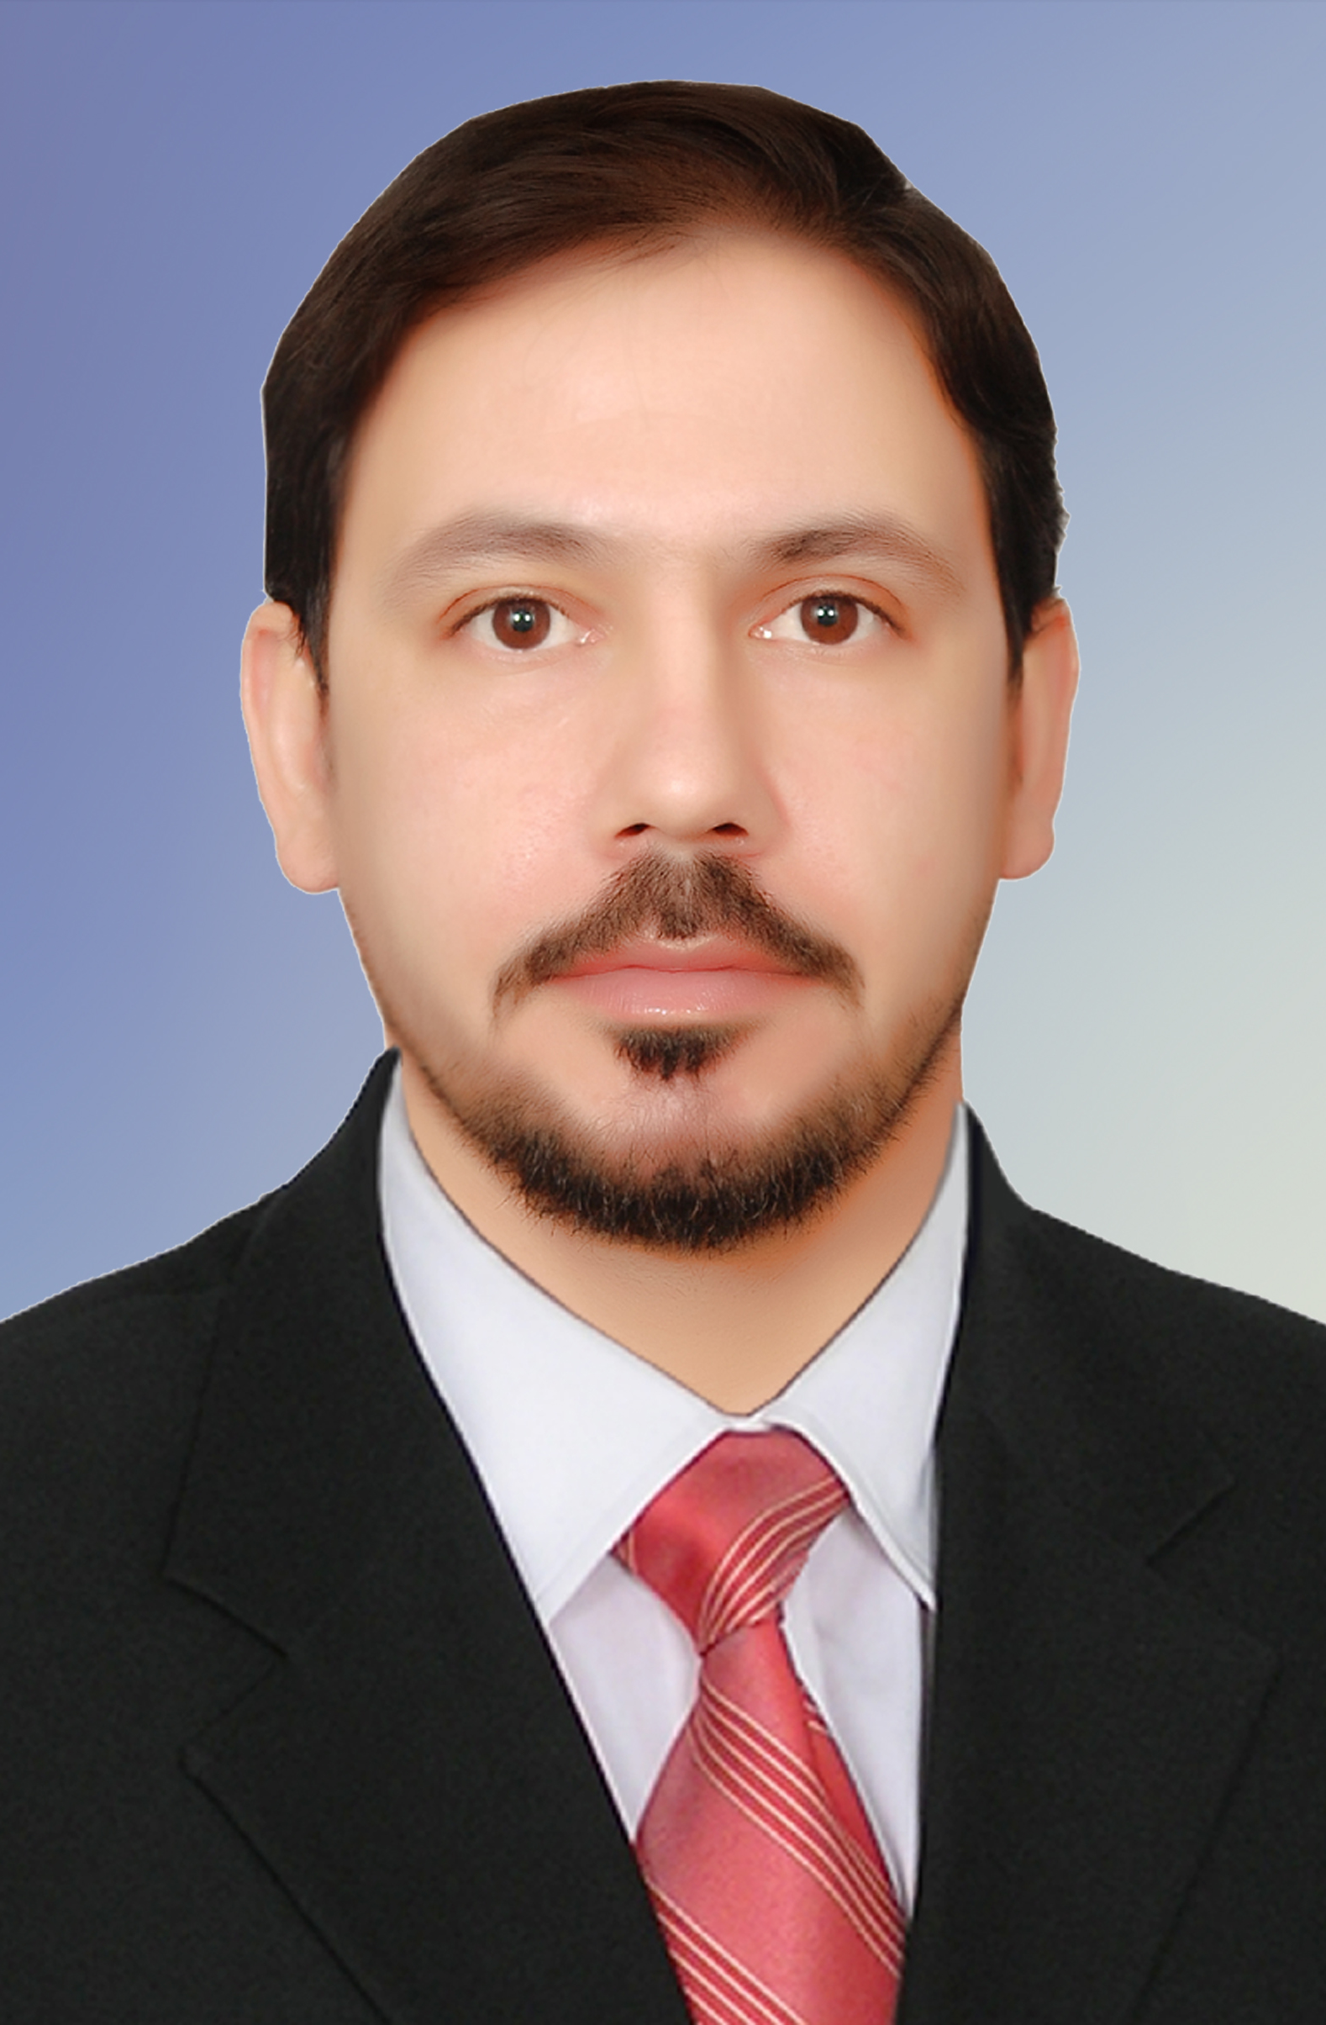
 | Personal Information | .
 | Academic degree: | Assistant Lecturer
 | Birth Date & Place: | July, 5, 1983 – Iraq
 | Nationality: | Iraqi
 | Passport Number: | A5468562 valid until April 24, 2018
 | Mobile: | Iraq\07716124647
 | Email: | omarimran53@yahoo.com
 | Website: | www.uodiyala.edu.iq
 | License: | Iraqi International Driving License.
 | Postal address: | College of Engineering, Diyala University, Ba’qubah City, Diyala Governorate,
 |  | ZIP 32001, Iraq.
Professional Strength and Skills .

- Professional strength and skills for participation and prestige of responsibility in the fields of electrical engineering (electrical foundations, electrical power and electronic engineering in digital and analogue circuit design and also interested in modern software that enable me to utilize my skills and theoretical experience to serve university teaching and work.
- Also interested in renewable energy, especially in the fields of solar cells and wind power

Educational Qualifications .
• | Ms. C. Electrical Energy | 2012 - 2013 | Belgorod Government Technology University Russia's Federal
• | B.Sc. Electronic Engineering | 2005 -2006 | College of Engineering – Diyala
 | University-Iraq. (English Curriculum).

Training and Courses .

- Computer Programming Course – University of Diyala.
- Methods of Teaching Course – University of Diyala.

Languages .
• |  | English: |  | Written and spoken (good)
• |  | Russia |  | Written and spoken (Very good)
 | Arabic: |  | Mother tongue.
Employment History (Academic & Technical) .
Diyala University – College of Engineering |  |  |  |  |  | (2007 – till now)
Location: Diyala – Iraq

Academic degree: Assist. Lect.

Description: Teaching Programming and Programming Lab. for the first and second stages and Engineering And Digital Electronics for the second stage.

Software .

- MatLab.
- Visual Basic.
- Qbasic.
- C++.
- Proteus.
- Arduino.
- Electronics Workbench.
- Multisim.
- Microsoft Office, Word, Excel, Power Point.

For more information visit the following link: .
SCOPUS
Research Gate | https://www.researchgate.net/profile/Omar_Imran
Acadimeca.edu | https://uodiyala.academia.edu/OmarAImran
Google Scholar | https://scholar.google.com/citations?user=5b6b8N4AAAAJ&hl=ar
LinkedIn
Facebook
Twitter

YouTube channel

Publons  https://publons.com/author/1219684/omar-a-imran#profile

Mendeley
Skype

